CHEMISTRY THEORY
PAPER 1

Marking scheme

1. Three pure pigments were prepared and their spots placed on a filter paper as shown below. The
three pigments are A, B and C. A mixture F was also placed on the filter paper at the same time
with the pure pigments. The filter paper was then dipped in ethanol solvent and left for some half
an hour. The results were obtained as follows.

• •
•
• •

• • • •
A B C F

•

baseline

(i) Which of the three pure pigments is most sticky? Give a reason for your answer. (1mk)

A – moves shortest distance

(ii) Which pure pigment is not present in the mixture F? (1mk)

B

(iii) Show on the diagram the baseline. (1mk)

2. Describe how a pure sample of lead (II) carbonate can be prepared in the laboratory starting with lead II oxide. (3mks)

Measure a fixed volume of nitric V acid in a beaker
Add lead II oxide to the acid until in excess
Filter the mixture and collect the filtrate lead II nitrate
To the filtrate add a solution of sodium carbonate solution to precipitate lead carbonate
Filter the mixture and collect the residue lead II carbonate wash the residue and dry it under low temperature or btw filter papers

3. The set up below was used to prepare nitric (V) acid in the laboratory.
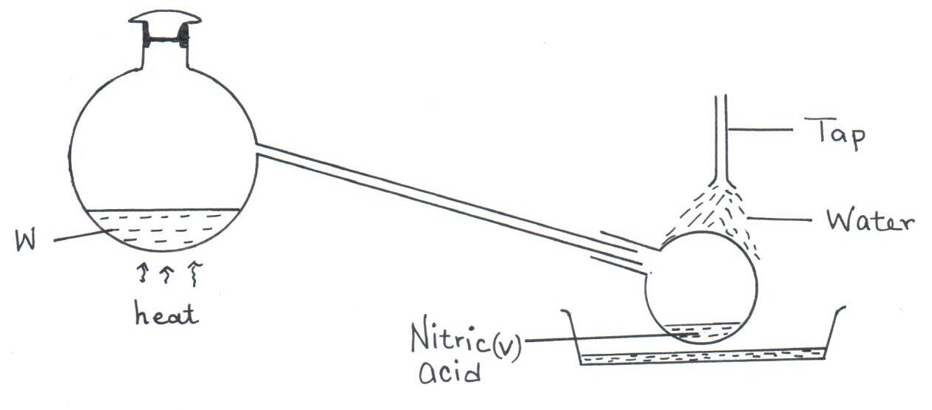

A.

(a) Name the mixture W. (1mk)

Conc. sulphuric (VI) acid + potassium nitrate

(b) Write an equation for the reaction that takes place in flask A. (1mk)

H₂SO_{4(l)} + KNO_{3(S)} → KHSO_{4(aq)} + HNO_{3(aq)}

(c) Explain why concentrated nitric (V) acid produced appears yellow when exposed to sun light (1mk )

Nitric (V) acid decomposes on exposure to light to form nitrogen (IV) oxide. (1mk)

4. A mixture contains ammonium chloride, aluminium oxide and sodium chloride. Describe how each solid substance can be obtained from the mixture. (3mks)

Heat the mixture ammonium chloride sublimes and is collected on the cooler part of boiling tube./accept a diagram
- Add water to dissolve NaCl.
- Filter to obtain Al₂O₃ as a residue.
- Evaporate the filtrate to obtain NaCl (3mks)

5. State the difference between the following salts;
Deliquescent and hygroscopic salts. (2mks)

Deliquescent – Absorbs water from atmosphere to form a solution.
Hygroscopic – Absorbs water from the atmosphere and do not form solution. (2mks)

6. Below is a set-up of apparatus used to investigate the effect of electric current on molten lead (II) bromide.
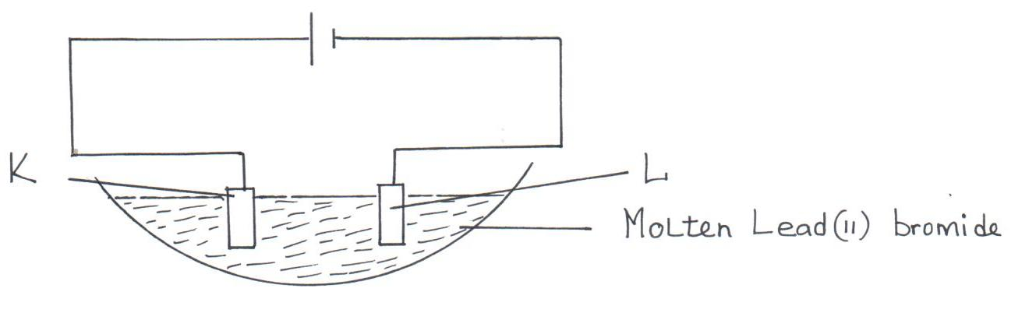

- Name electrode. (1mk)

K Anode

L Cathode
(b) State the observation made at electrode K. (1mk)

Red-brown vapour

(c) Write an equation for the reaction taking place at electrode L. (1mk)

7.A sample of a polymer has the following structure.

H H H H H H
| | | | | |
⎯ C ⎯ C ⎯ C ⎯ C ⎯ C ⎯ C ⎯
| | | | | |
H H H H H H

a) Draw the structural formula of the monomer that makes the above polymer
a)Mass of monomer H H
C==C

H H

b)The polymer is found to have a molecular mass of 2268g. Determine the number of monomers in the polymer. (H = 1., C = 12). (1mk)

b) 2268/28 = 81 monomers

8. Study the information given in the table below and answer the questions that follows.
Solid H
Brown fumes +
Solid K
H₂SO_{4(aq)}
Solution B + H₂O
a gas that rekindles a glowing splint

White
ppt
1 drop of

NH_{3(aq)}
Colourless solution T
Excess NH_{3(aq)}

- Predict the cation and anion present, in solid H.

Cation _____________________________________ (1mk)

Anion ______
(1mk)

- Identify solid K, solution B and white-precipitate.

Solid K __________________- ZnO __________________________________ (1mk)

Solution B ________________ ZnSO₄ ____________________________________ (1mk)

White precipitate(ppt) ____________ Zn(OH)_{2(S)} _______________(1mk)

9.The isotopes hydrogen are H and H. Determine the molecular masses of the molecules formed when each of these isotopes react with chlorine. (Cl = 37) (2mks)

Molecule: HCl
MM. of ¹₁ HCl = 38
Of ²₁ HCl = 39

10. The table below gives the atomic numbers of elements W,X,Y and Z. The letters do not represent the . actual symbol of the elements
Element | A | B | C | D
Atomic number | 9 | 10 | 11 | 12
a) Which one of the elements is un reactive? Explain (1mk)
B. has completely filled outer energy level

b)i) Which two elements would react most vigorously with each other? (1mk)
(i) A and C

ii) Give the formula of the compound formed when the elements in b (i) above react (1mk)
CA //NaF reject AC

11a) Distinguish between a hydrogen bond and dative covalent bond (2mks)

hydrogen bond is formed between a hydrogen atom of one molecule with a more electronegative/an oxygen of another element of another molecule. (accept illustration e.g
O
H H
O
H H

Covalent bond is formed when two electronegative elements bond by each donating an electron to be shared in the bond.

b) Explain why the boiling point of water is higher than that of hydrogen Sulphide
(Relative molecular mass of water is 18 while that hydrogen sulphide is 34) (2mks)
Water has hydrogen bonding in addition to vanderwaals forces which makes the intermolecular force strong requiring more energy, while hydrogen sulphide has only weak vander waals forces which requires less energy to break. .

12. In an attempt to investigate the properties of halogens, a student bubbled chlorine gas through a solution of potassium bromide.
(a) State and explain what was observed.
(2mks)
Brown/Orange solution formed. Chlorine displaces bromine from its solution.

(b) Write an ionic equation for the reaction. (1mk)

+ Cl_{2(g)} → + Br_{2(g)}

(c) Explain why iodine sublimes when heated to form a purple vapour. (1mk)

Iodine molecules are joined together by weak intermolecular forces of
Attraction/weak van der waal forces that are easily broken on heating. (1mk)

13. The set-up below was used to investigate the products of burning methane gas. Study it and answer the questions that follow:
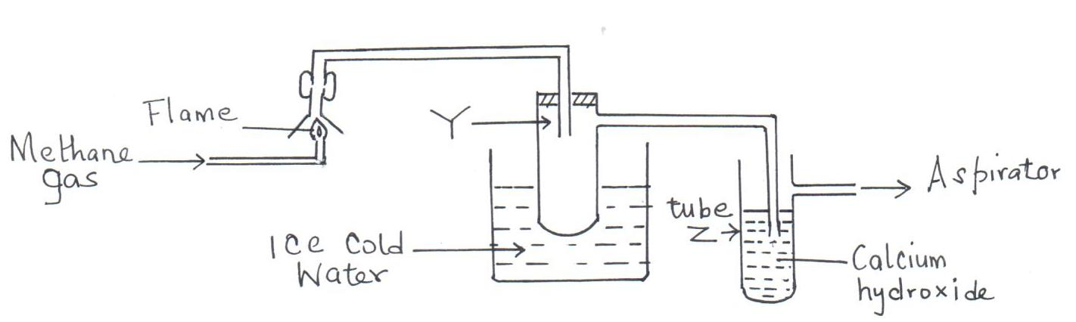

(a) What product will be formed in the test tube Y? (1mk)

Water/H₂O

(b) State and explain the observations made in tube Z. (2mks)

A white precipitate. ½ Burning methane produces carbon (IV) oxide ½
Which reacts with calcium hydroxide to form the insoluble ½ calcium carbonate ½

14. Below are P^{H} values of some solutions.
Solution | Z | Y | X | W
P^{H} | 6.5 | 13.5 | 2.2 | 7.2

- Which solution is likely to be

I Acidic rain. Z
(1mk)

II Potassium hydroxide Y (1mk)

- A basic substance V reacted with both solutions Y and X. What is the nature of V. (1mk)

Amphoteric

15. In cold countries, salt is sprayed on the road to melt ice but in the long run it costs the motorists.
(a) How does the salt help in melting ice? (1mk)

Salt acts as an impurity. Lowers Mpt of ice hence ice melts at low Mpt.

(b) How does the salt affect the motorists?

Salt increases rate of rusting of the metallic parts of the vehicles. (1mk)

16. Using dots ( ) and crosses (x) to represent electrons, show bonding in the compounds formed when the following elements react: (Si=14, Na=11, Cl=17).
- Sodium and chlorine. (2 Mks)
+
-
Na
Cl

Si

- Silicon and chlorine. (2 Mks)
Si
Cl

Cl
Cl

Cl

17. (a) Define Graham’s law of diffusion.

Under the same conditions of temperature and pressure, the rate of diffusion
of a gas is inversely proportion to the square root of its density. (1mk)

- 20cm³ of an unknown gas Q takes 12.6 seconds to pass through small orifice, 10cm³ of
oxygen gas takes 11.2 seconds to diffuse through the same orifice under the same conditions
of temperatures and pressure. Calculate the molecular mass of unknown gas Q (O = 16).
(3mks)

RQ₁= RMMof Q₂
RQ₂ RMMof Q₁

= 10.13 M

18. The peaks below show the mass spectrum of element X.
9.1
8.1
82.8
24
25
26
Isotopic mass
Intensity
(% abundance)

Calculate the relative atomic mass of X. (2mks)

=
=
= 24.263

19. Name the following compounds using the IUPAC rules.
(a) CH₃CH₂CHCH₂CH₂CH₃
|
CH₂CH₃ ___________3-ethyl hexane (1mk)
(b) CH₃CHCHCH₃ _________ But-2-ene ______ (1mk)

(c) Draw TWO structural formulae of isomers of compound with the molecular formula CH₃CH₂CH₂CH₃

(2mks)

H H H H
| | | |
H ⎯ C ⎯ C ⎯ C ⎯ C ⎯ H ¹
| | | |
H H H H

H H H
| | |
H ⎯ C ⎯ C ⎯ C ⎯H ¹
| | |
H CH₃ H

20.(a) What is meant by allotropy? (1 Mk)

allotropy is the existence of an element in more than one form without change in physical state

b) The diagram below shows the structure of one allotropes of carbon.

i) Identify the allotrope ( 1 Mk)

graphite

ii) State one property of the above allotrope and explain how it is related to its structure. (2Mk) .
it is a lubricant because layers slide over each other//
– a good conductor of both heat and electricity because it has delocalised/mobile electrons

21. 24cm³ of a solution of 0.1M potassium hydroxide were exactly neutralized by 30cm³ of a solution of sulphuric acid. Find the molarity of the acid. (3 Marks)

2KOH_{(aq)} + H₂SO_{4(aq)} → K₂SO_{4(aq)} + 2H₂O ½
0.0024 0.0012
Moles of KOH_{(aq)} = ½
Moles of H₂SO_{4(aq)} =
= 0.0012 ½
Molarity of H₂SO₄ =
= 0.04M ½ (3mks)

22. (a) Give one use of hygroscopic substances in the laboratory. (1 Mark)

used as drying agents for wet gases/test presence of water

(b) What is meant by the terms: (2 Marks)
- Isotopes

Isotopes are atoms with same number of protons/atomic numbers but different number of neutrons/mass numbers

- Mass number

Mass number is the total number of number of protons and neutrons in an atom.

(c) The formulae for a chloride of phosphorus is PCl₃. What is the formula of its sulphide?
(1 Mk)
P₂S₃

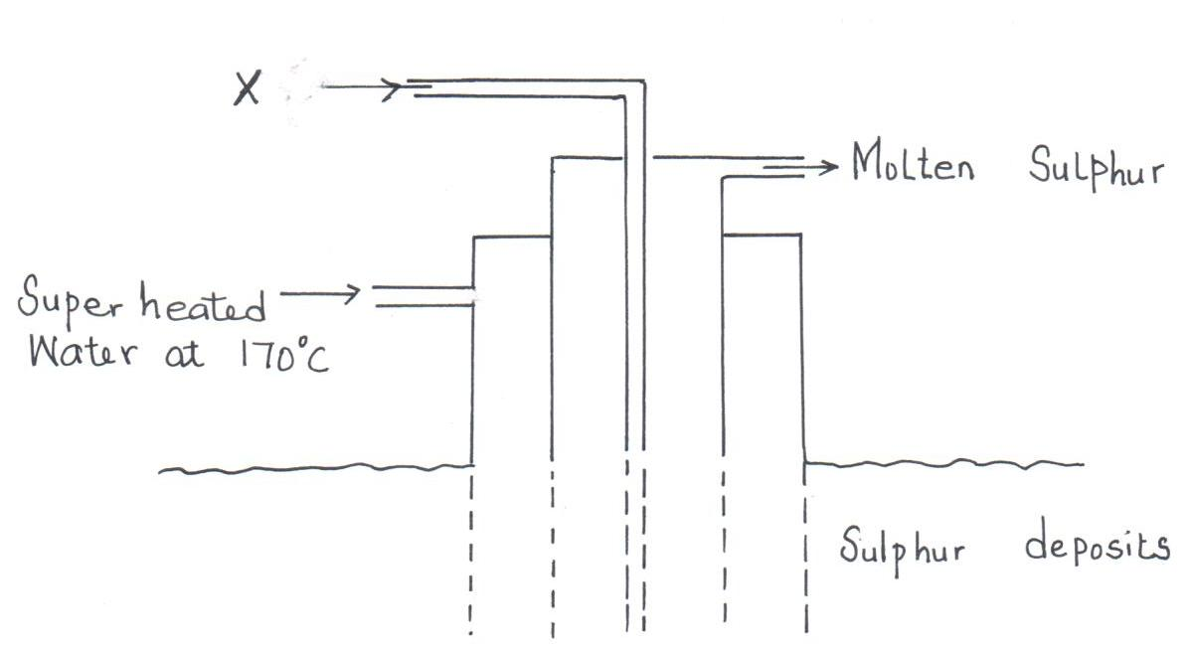
23. The diagram below shows the Frasch process used for extraction of sulphur. Use it to answer the questions that follow.

(i) Identify X. (1mk)

Hot compressed air.

(ii) Why is it necessary to use super heated water in this process? (1mk)

To melt sulphur

(iii) State two physical properties of sulphur that makes it possible for it to be extracted by this method. (1mk)

- Low melting point
- Does not dissolve in water (1mk)

24. A certain carbonate XCO_{3 ,} reacts with dilute hydrochloric acid according to the equation given below:
XCO_{3(s)} +2HCl _{(aq)} XCl_{2 (aq)} + CO_{2 (g)} + H₂O _{(l)}
If 4g of the carbonate reacts completely with 40cm³ of 2M hydrochloric acid, calculate the relative atomic mass of X. (C=12.0 ,O=16.0, Cl=35.5). (3 Mks)

No. Of moles of HCl in 40cm³ of 2M HCl
= 40cm³x2M
1000
=0.08moles
Mass of HCl in 0.08moles = 36.5 x 0.08
= 2.92g
4g of the XCO₃ reacts with 2.92g 0f HCl.
X + 60g of XCO₃ reacts 2 x 36.5g of HCl
2.92(X+60)g=4x2x36.5g
2.92X+175.2 = 292
2.92X=292-175.2
=116.8
X= 116.8/2.92
=40

25. Concentrated sulphuric acid is slowly added to a mixture of freshly prepared solution of iron (II) sulphate and potassium nitrate as below.
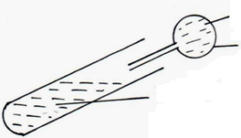
Concentrated sulphuric (VI) acid
Teat pipette
Mixture of iron (II) sulphate and potassium nitrate solution

(i) State the observation made. (1mk)
A brown ring

26. The table below gives some properties of three substances I, J and K. Study it and answer the questions that follow.

Substance | Mpt (°C) | Solubility in water | Electrical conductivity  Solid Molten
I | 1063 | Insoluble | Conduct Conduct
J | 113 | Insoluble | Doesn’t Doesn’t
K | 402 | Sparingly soluble | Doesn’t Conduct and  is decomposed

- Suggest the type of structure in

(i) I Giant metallic ¹ Reject metallic (1mk)

(ii) K Giant ionic ¹ Reject ionic (1mk

Explain why the molten K is decomposed by electric current but I is not decomposed. (2mks)

K is an ionic compound while I is a a metallic element with mobile electrons

